PROJECT 7
PRINTER & PERIPHERAL TROUBLESHOOTING
Practical Device Inspection, Testing and Findings
Portfolio learner | Samah Iris Afua Harriet
Project | 7 of 8 – Printer & Peripheral Troubleshooting
Environment | Windows 11 Pro Education | TM1 laptop

1. Project Overview
This project focused on inspecting printers and peripheral devices in Windows, checking device recognition and status in Device Manager, and carrying out available functionality tests. The learner did not have access to a physical printer or USB flash drive, so the printer exercise used the Windows virtual printer Microsoft Print to PDF, while USB hardware was inspected through Device Manager.

2. Printer Inspection and Test
The Windows Settings page at Bluetooth & devices > Printers & scanners listed Fax, Microsoft Print to PDF, Microsoft XPS Document Writer and OneNote (Desktop). These are printer-related entries, including virtual printers; no physical printer was available for a paper-print test. Microsoft Print to PDF was shown as the default printer.
The learner selected Microsoft Print to PDF from Microsoft Word's print screen. Word displayed the document in Print Preview, and the learner confirmed that the PDF was successfully saved. This verifies the virtual PDF-printing workflow, but does not test a physical printer, paper feed, ink/toner, or a network printer connection.

3. Bluetooth Inspection and Troubleshooting
Bluetooth was switched on. Windows detected nearby Bluetooth devices, including a Samsung TV. The learner reported that no devices were listed as paired at the time of the initial check. Device Manager showed the Realtek Bluetooth Adapter and related Microsoft Bluetooth components. No warning symbol was visible beside the adapter in the supplied screenshots.
The Realtek Bluetooth Adapter Properties page reported that the device was working properly. The Driver tab identified Realtek Semiconductor Corp. as the provider, with driver date 9 September 2020 and version 1.8.1030.3007. The Power Management tab showed that Windows was allowed to turn off the adapter to save power. During the exercise, that option was unticked and the change was saved.
After the change, the laptop remained visible to the iPhone, and the laptop detected other nearby Bluetooth devices. The iPhone did not appear in the laptop's discovery results. This does not establish a general Bluetooth hardware failure: discovery of other nearby devices was successful. The iPhone-specific discovery/pairing issue remained unresolved and was documented without forcing a pairing or changing unrelated settings.

4. USB Controller Inspection
The Universal Serial Bus controllers category was expanded in Device Manager. The visible entries included Generic USB Hub, Intel USB 3.0 eXtensible Host Controller, Realtek USB 2.0 Card Reader, USB Composite Device entries and USB Root Hub (USB 3.0). No yellow warning symbols were visible in the screenshot.
No USB flash drive or other external USB device was available, so a physical insertion and data-transfer test could not be performed. The USB work is therefore recorded as a controller and device-list inspection only, not a confirmed functional test of each physical port.

5. Camera, Microphone and Speaker Checks
Device Manager listed PC Camera under Cameras. The camera's Properties > General page reported: “This device is working properly.” The learner then opened the Windows Camera app and confirmed that the camera worked and displayed a live image.
The learner also confirmed that the laptop microphone and speakers were working. These audio checks were user-confirmed; no separate diagnostic screenshots or detailed audio measurements were recorded.

6. Summary of Results
Check | Result | Finding
Printer list inspection | Completed | Virtual printer entries identified; no physical printer available.
Microsoft Print to PDF | Passed | Word print preview worked and PDF saved successfully.
Bluetooth hardware inspection | Passed | Realtek adapter detected; Windows reported it was working properly.
Bluetooth discovery | Partially passed | Other nearby devices detected; iPhone did not appear in laptop discovery.
Bluetooth power management | Adjusted | Windows power-saving option to turn off the adapter was disabled.
USB controller inspection | Completed | USB controller entries visible; no warning symbols observed; no external USB device to test.
Built-in camera | Passed | Device Manager reported proper operation; Camera app displayed live image.
Microphone and speakers | Passed | Learner confirmed both were working.

7. Troubleshooting Knowledge Demonstrated
- Navigating Windows Settings to inspect installed printers and scanners.
- Distinguishing virtual printers from physical printers.
- Testing the Microsoft Print to PDF workflow from Word.
- Using Device Manager to inspect Bluetooth adapters, USB controllers and camera hardware.
- Reading device status and driver information without making unnecessary changes.
- Recognising that an older driver date alone does not prove that a driver is faulty.
- Checking Bluetooth power-management settings and retesting device discovery.
- Recording limitations accurately when physical test equipment is unavailable.

8. Conclusion and Further Recommendations
The available printer and peripheral checks were completed. Microsoft Print to PDF successfully created a PDF file. Windows detected the Bluetooth adapter and reported that it was working properly; other nearby Bluetooth devices were discoverable, although the iPhone did not appear in the laptop's search results. USB controllers were visible in Device Manager, but physical USB-port operation was not verified because no external USB device was available. The camera, microphone and speakers were confirmed to work.
For a fuller hardware validation, a future session should include a physical printer test (printing a test page), a USB flash-drive test (detection and file access), and a controlled Bluetooth pairing test with a compatible accessory. No hardware replacement or driver reinstallation is recommended based on the evidence collected in this project.

9. Screenshot Evidence
Selected screenshots from the practical session are included below as evidence of the Windows settings, device inspections and tests.
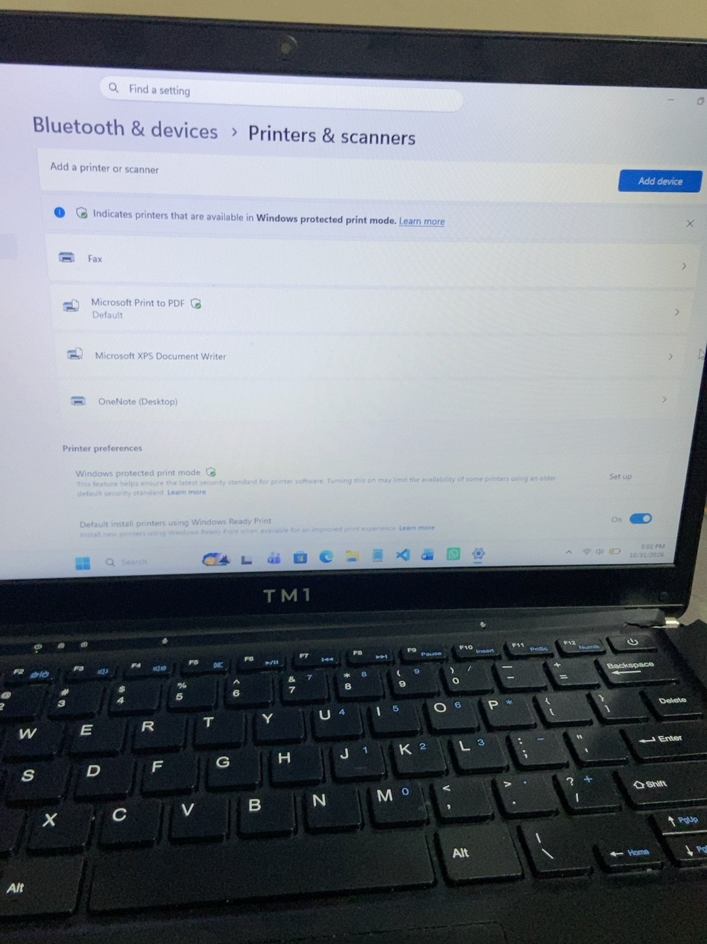
Figure 1. Windows Printers & scanners page showing available printer-related entries.
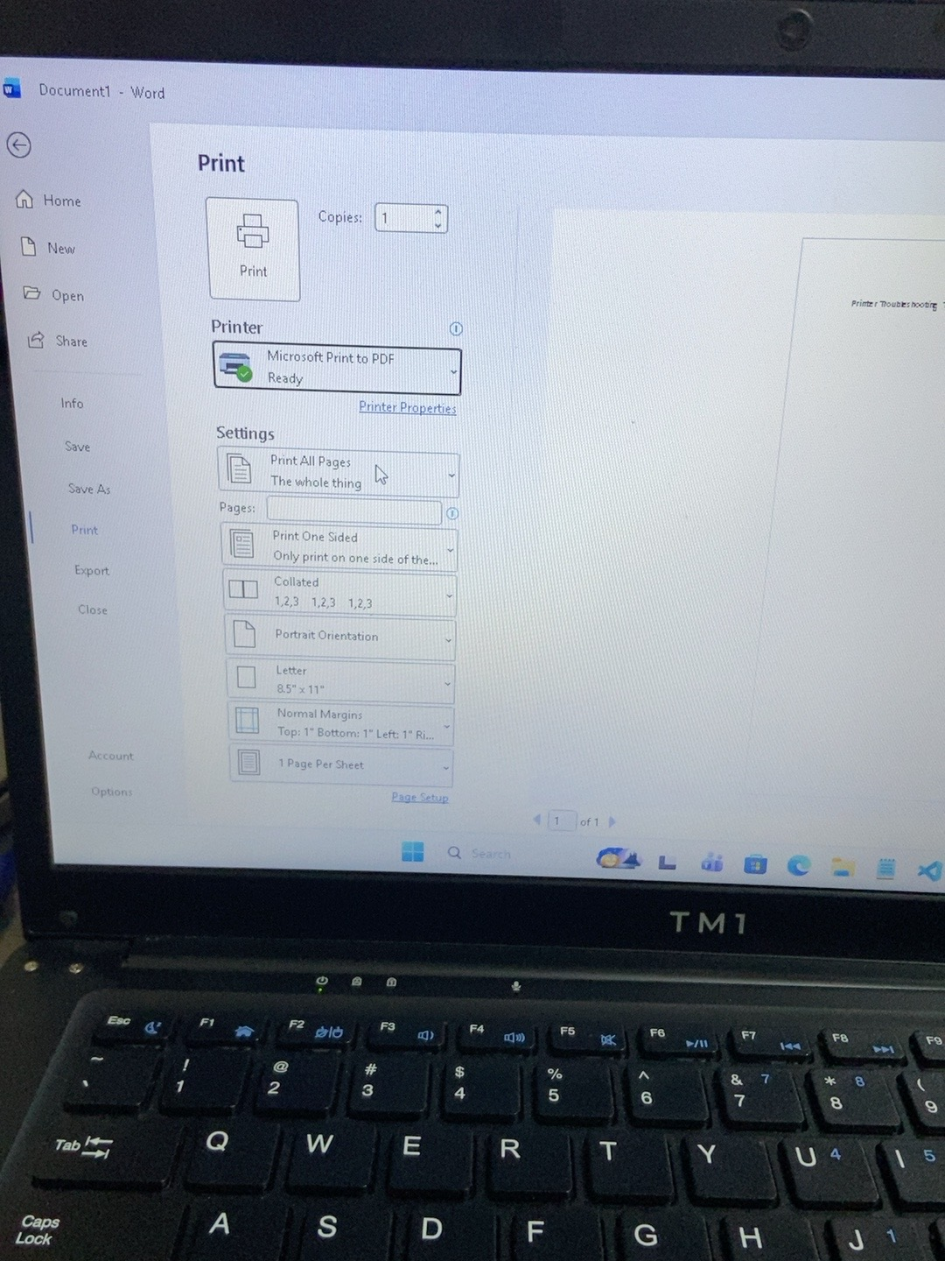
Figure 2. Microsoft Word print screen with Microsoft Print to PDF selected.
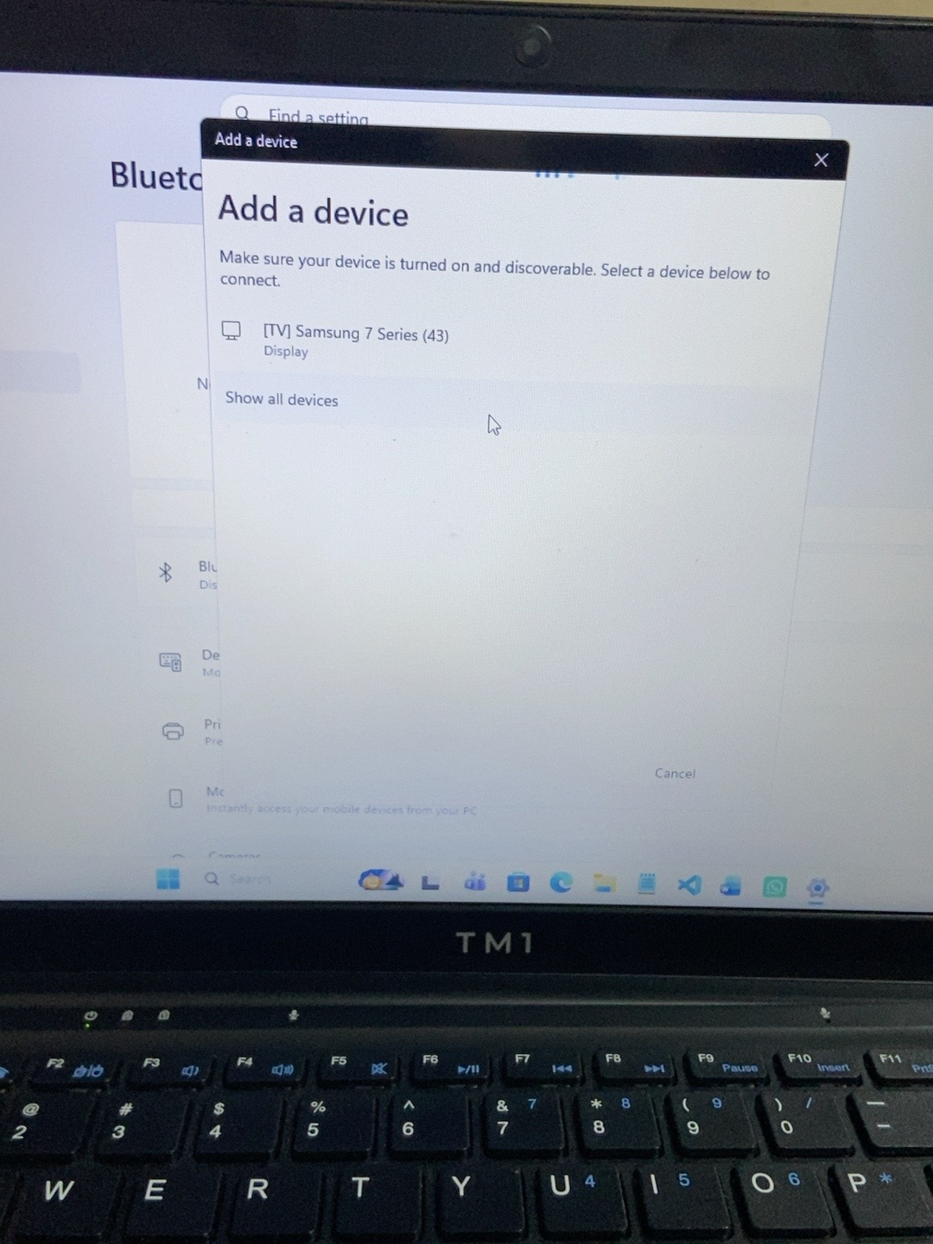
Figure 3. Windows Bluetooth device discovery showing a nearby Samsung TV.
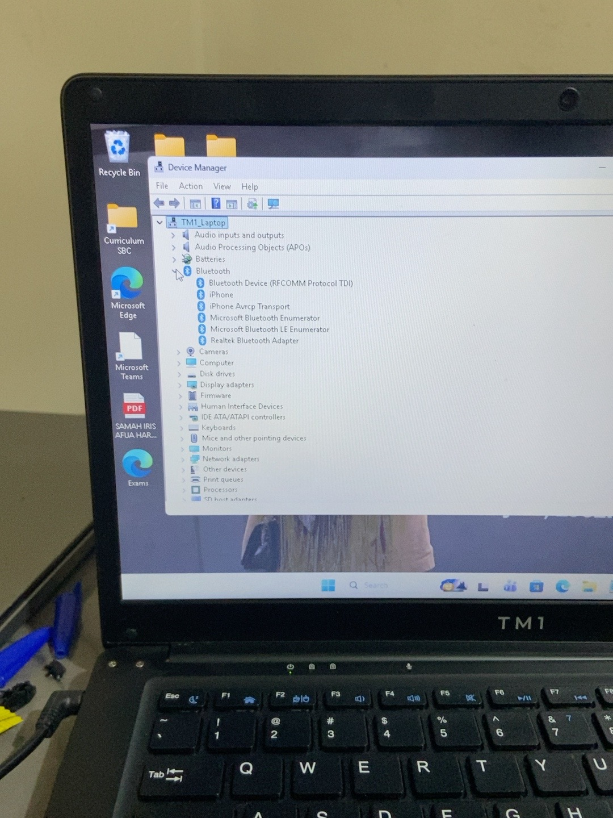
Figure 4. Device Manager showing Bluetooth components and the Realtek Bluetooth Adapter.
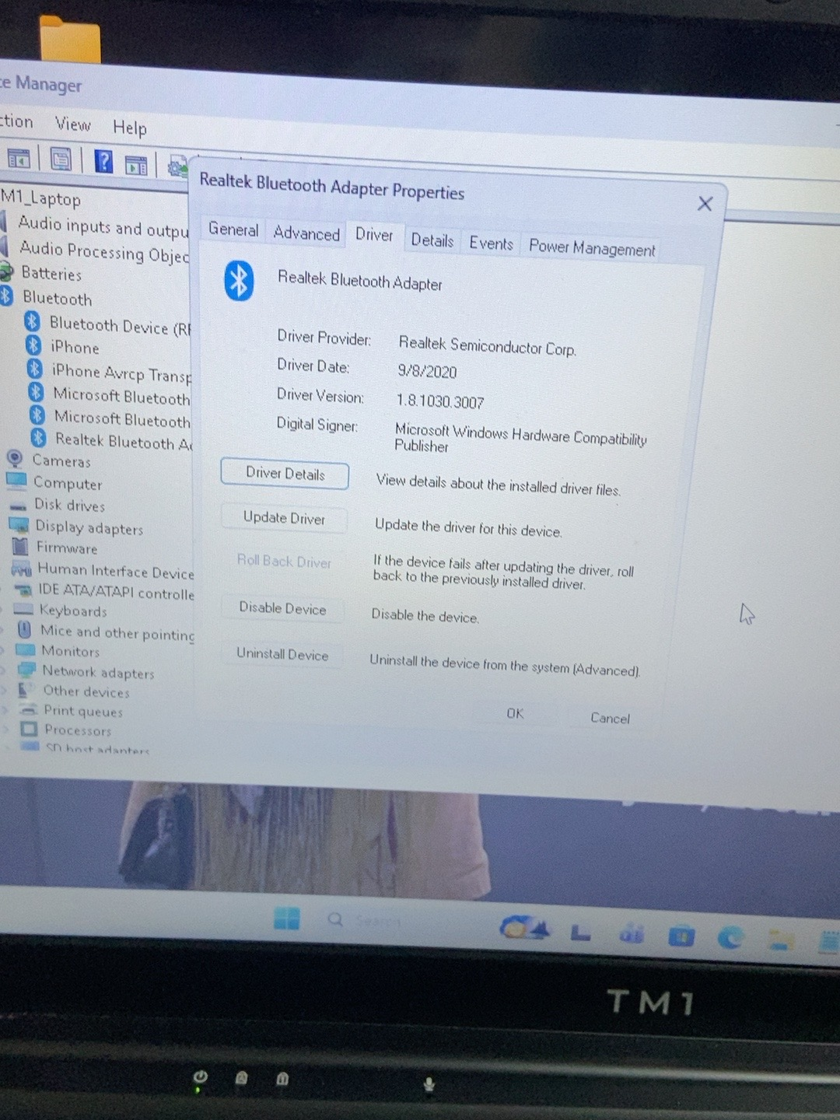
Figure 5. Realtek Bluetooth Adapter driver information.
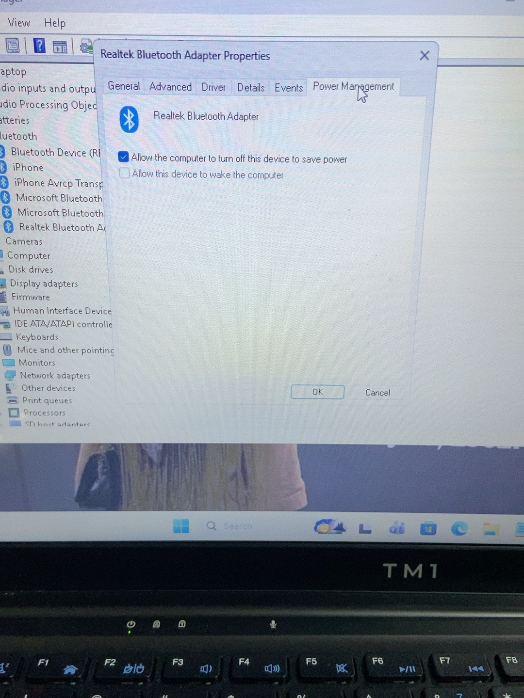
Figure 6. Bluetooth adapter Power Management settings.
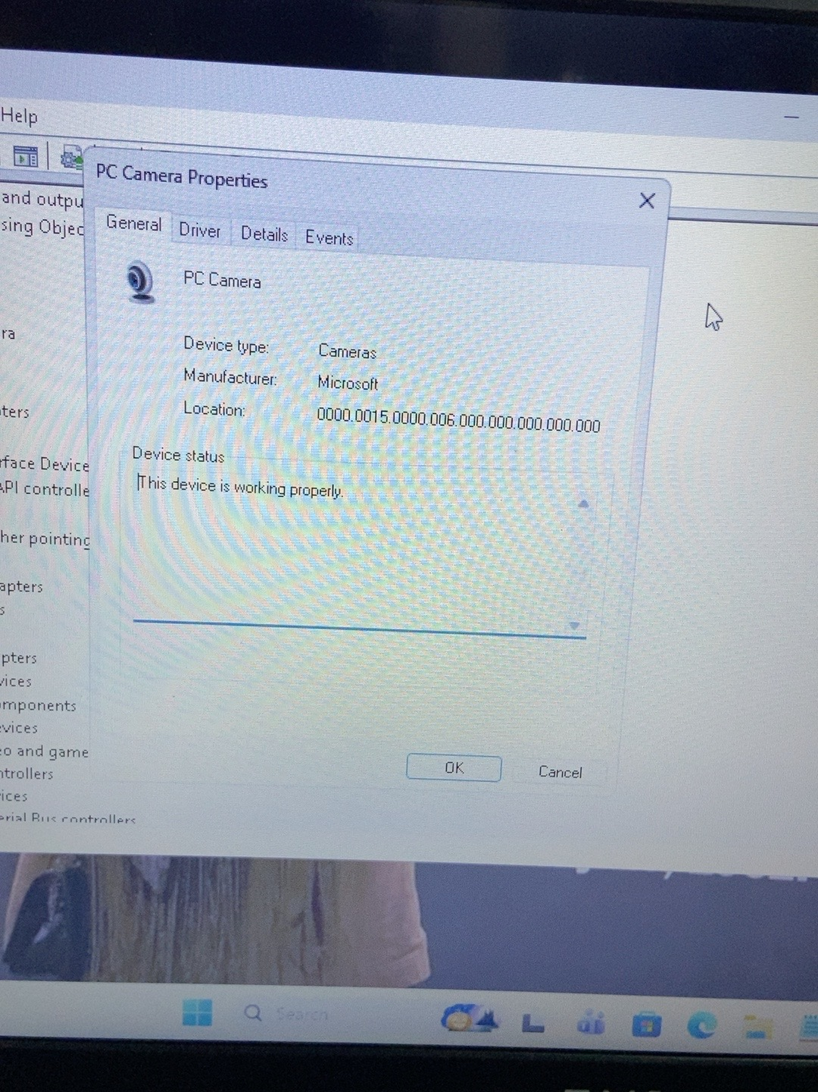
Figure 8. PC Camera device status in Device Manager.
END OF PROJECT 7 DOCUMENTATION

